**12th Annual**

**Rev. Albert E. Chew, Jr.**

**Memorial Golf Tournament**

Benefiting   
Inner-City Boy Scouts Troop 528

**June 24, 2023**

Waterchase Golf Club

8951 Creek Run Road

Fort Worth, TX 76120

Individual Golfer, Team & Sponsorship

Registration

Name: ___________________________________________

Company: ________________________________________

Phone Number: ___________________________________

Email: ___________________________________________

Address: _________________________________________

City & State: _______________________________

Early Bird Registration for the first 24 Golfers is $112.50 per Golfer by June 2, 2023; Registration of $125 per

Golfer from June 3 – June 25.

**Golfer’s Name, Cell Phone & Email**

1. ____________________________________________
2. ____________________________________________
3. ____________________________________________
4. ____________________________________________

**Sponsor Pkg**.: ________________________________________

You can register online at [www.shilohfortworth.com](http://www.shilohfortworth.com) or complete and submit this form with your check(s) made payable to:

**Shiloh Missionary Baptist Church:** (Note Inner-City Boy Scouts or ICBS on Memo Line).

**Attn**: Daphne Martin

2823 North Houston Street

Fort Worth, TX 76106

817-626-5592

Online Registration

[www.ShilohFortWorth.com](http://www.ShilohFortWorth.com)

[PayPal.svg](https://en.wikipedia.org/wiki/File:PayPal.svg)

https://www.paypalobjects.com/en_US/i/scr/pixel.gif

https://www.paypalobjects.com/en_US/i/scr/pixel.gif



Troop 528 Sponsor

Shiloh Missionary Baptist Church

[www.ShilohFortWorth.com](http://www.ShilohFortWorth.com)

***12th Annual***

***Rev. Albert* E. Chew, Jr.**

**Memorial Golf Tournament**

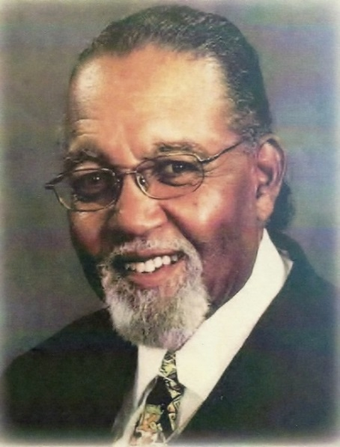

Benefiting

Inner-City Boy Scouts

**June 24, 2023**

**8:00 A.M. Shotgun Start**

Waterchase Golf Club

8951 Creek Run Road

Fort Worth, TX 76120

**12th Annual**

**Rev. Albert E. Chew, Jr.**

**Memorial Golf Tournament**

Benefiting Inner-City

Boy Scouts

Troop 528

Boy Scout Troop 528 is providing leadership skills, knowledge, and character for boys to become productive citizens of tomorrow. Troop 528 has 13 Eagle Scouts with approximately 80% of scouts going to college or the military.

The proceeds from the tournament will aid in the inner-city scouts’ program, various camps and associated travel cost. Members of Troop 528 accepts the challenge of becoming productive citizens by using the **SCOUT HANDBOOK** and the **BIBLE** as their guide.

**The Tournament**

Green Fees, Cart Fees, Range Ball,

Professional Bag Drop Service and Lunch

Four – Man/Woman Scramble

* 1st, 2nd, and 3rd Place Teams
* Hole-in-One
* Closest-to-Pin Man & Woman
* Longest Drive Man & Woman

**Tournament Challenges**

(Credit Card or Cash)

* On-the-Green: $50 gift certificates or Team Birdie
* Use Dixon “Earth” Ball
* Hole-in-One shot at Million Dollar Fiesta Bowl
* $10,000 Hole-in-One from 160 yards (only 4 golfers chosen by ticket pull)

**Par 5**

* Hula Hoop: $300 in Gift certificates and 2 raffle tickets for the Aurelius Driver
* Get in 1 of 10 Hoops from 165 yards and win an Aurelius Driver or Team Move-up (100 yards)

**Donations**

If you are unable to play or be a sponsor, but would like to make a difference in a young man’s life, consider making a donation at [www.shilohfortworth.com](http://www.shilohfortworth.com) or by check made payable to Shiloh Missionary Baptist Church with ICBS on the memo line. Thank you for your generosity and support.

**Tournament Chair**

Daphne Martin------------817-729-8999

**Committee**

Willa Gipson-----------------------817-680-9610

Tony Lampkin---------------------817-501-8873

George Shinn----------------------817-870-0050

Kelly Vandewalker----------------817-680-9610

**Sponsorship**

**Platinum Sponsorship**------------------$2,500

* Two Teams (8 Players)
* Company Logo on Golf Balls & Banner
* Players will receive a sleeve of Balls
* Letter of Appreciation

**Gold Sponsorship**------------------------$1,500

* One Team (4 Players)
* Company Logo on Banner
* Letter of Appreciation

**Silver Sponsorship**----------------------$1,000

* One Team (4 Players)
* Two Signs
* Letter of Appreciation

**Bronze Sponsorship**-----------------------$500

* Two Golfers (2 Players)
* One Sign
* Letter of Appreciation

**Hole Sponsorship**--------------------------$110

**Golf Clinic**-------------------------------------$50

A two-hour session on the fundamentals by PGA instructor and lunch. Minimum of 10 needed.

To ensure signage is printed in time, **Sponsorship** payment and logo deadline is Friday, June 2, 2023.